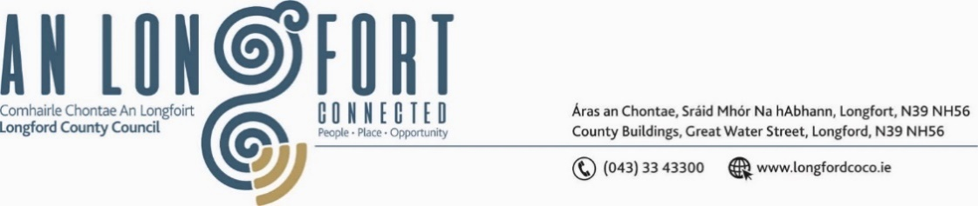

***LONGFORD MUNICIPAL DISTRICT***

***Please note meeting will be held in Aras an Chontae and via Microsoft Teams.***

**20 June 2023**

**To: Each Member of Longford Municipal District.**

A Chomhairleoir,

You are requested to attend the Annual Meeting of Longford Municipal District to be held in **the Council Chamber, Aras an Chontae, Great Water Street, Longford and via Microsoft Teams on Wednesday, 28 June 2023 at 3pm** to transact business, as set out on the Agenda hereunder.

Mise le meas,

______________

**Claire McNabola,**

**Meetings Administrator.**

**C L A R**

**1**. Election of Cathaoirleach

**2.** Election of Leas Cathaoirleach

**3**. Fix date and time of Longford Municipal District meetings

